BUNCH GUIDES
20 Cool Facts You Didn’t Know About the Mars Curiosity Rover
by Kait Fowlie (2012)

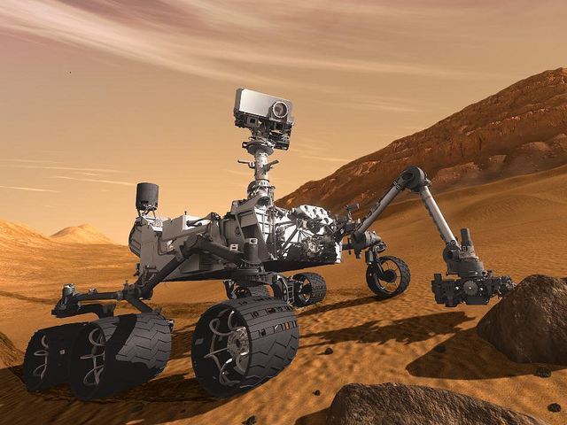
Curiosity just spent it’s first weekend rolling around the dunes, canyons, volcanoes of Mars. (And what did you do this weekend?) It’s taking pictures and videos, scraping up soil samples and lazer zapping rocks. Keep up with it’s busy schedule on Twitter. And your little space fans will definitely want to — after all, scientists believe that if life could exist anywhere in space, Mars would be the place.
Who knows— maybe the Rover is making blueprints for martian ‘hoods as we speak?
Here are 20 fun fast facts about the Mars Rover.
1. The lasers fixed on top of the rovers “head” can shoot at a distance of up to 23 feet and vaporize anything in their path! Vaporize! The vaporized substance can be analyzed by scientists to see if the landscape of Mars is toxic.
2. Curiosity has 17 cameras that can take pictures as tiny as 12.5 microns. That’s smaller than the width of a human hair.
3. Martian rocks won’t know what hit them — Curiosity will be able to bore deeper into martian rocks than any other rover on Mars has ever achieved thanks to a handy dandy two-inch drill on the end of one of it’s “arms.”
4. Curiosity will spend at least two years on Mars, but it’s only expected to travel between three to 12 miles the entire time. That means it will have an average speed of less than 0.00073 mph. Slow and steady, as they say
5. Its built-in nuclear power plant is capable of generating electricity for up to 14 years. Now, that’s what we call power!
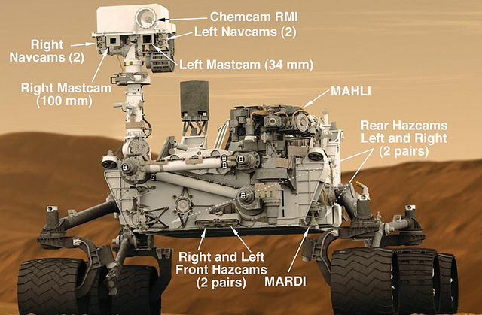
6. Curiosity may be the largest and most sophisticated rover to ever reach Mars, but the iPhone 4 is actually 4 times as powerful. Don’t you feel a little more important now?
7. Curiosity got it’s inspirational name from a 6th grader in Lenexa, Kansas who entered the 2008 student naming contest. We’re kind of curious to know what the other kids came up with.
8. Curiosity is one big bad boy— it weighs 1,982 pounds on earth, about the weight of a Mini Cooper.

9. The rover graced Mars at a speed of 13,200 mph, and it’s entry period was called the seven minutes of terror. Dramatic!
10. NASA doesn’t know where Curiosity’s jetpack lander crashed after it detached. Although NASA maintains this was part of the plan, (they didn’t want it getting in the way of Curiosity’s route), we wonder where it is now?
11. The one-ton Rover was lowered onto the planet with a 51 foot wide parachute. That’s a pretty massive chute!
12. Curiosity isn’t alone on Mars— there are currently 2 other rovers, Spirit and Opportunity. Spirit conked out a while back, but Opportunity has been prowling around since 2004. We hope it’s not territorial. Just in case it is, curiosity is ten times bigger anyway.
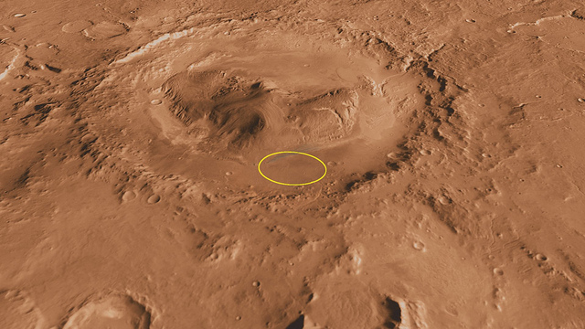
13. The rover’s wheels have treads that print the letters “JPL” (rumoured to stand for Jet Propulsion Laboratory) in morse code in the sand with every turn. Scientists back on Earth wanted to be able to look at photos of the wheel tracks and determine distances driven (not to mention make cool tracks on Mars).
14. It took eight months for the rover to make it to Mars from Earth. We can practically hear the “are we there yet?”s.

15. Of the 39 missions to the red planet, 24 have failed. Not only is Curiosity is looking good so far, but it’s our most promising chance of finding signs of life on Mars—it landed at a carefully chosen crater at the foot of a mountain, a great place to look for life because scientists indicate that water once flowed down it.
16. What if Curiosity gets stuck in a ditch? Who will be there to help a brother out? Thankfully, Curiosity was designed to be self sufficient, with an independent suspension and drive motor so it can roll over 30 inch boulders.
17. To measure the high radiation levels on Mars? A toaster-sized RAD. We wonder if there is toast involved in these tests.
18. What did Obama say to NASA after Curiosity landed? “If in fact you do make contact with Martians, please let me know right away”. Should we be worried?
19. Radio signals take 14 minutes to travel from Mars to Earth, so the Rover was already sitting around on Mars for 14 minutes before anyone knew. We hope it wasn’t too bored.

20. Curiosity has lent itself to many art renderings, including UPEI professor Tim Goddard’s meticulously detailed LEGO version. Get your kid to try their hand at their own personalized rover! You can even get your own LEGO digital design kit.
Photos by nasablueshift, usembassy jakarta, kenjonbro, nasamarshall, Johnson cameraface via Flickr.
Directions:

1) Actively read by underlining, writing your thoughts or opinions, and questions. Please write at least 3 annotations per page (underlining does not count)
2) Draw a star * next to structures that you think your ROV should have to help it explore your planets.
3) Below record each structure and why you want to include it on your ROV (at least 3).

