Biology Final Project Spring 2014
Goals:
- Review vocabulary related to the characteristics of living things
- Apply your knowledge of living things, scientific research, experiments and evolution to identify an unknown object
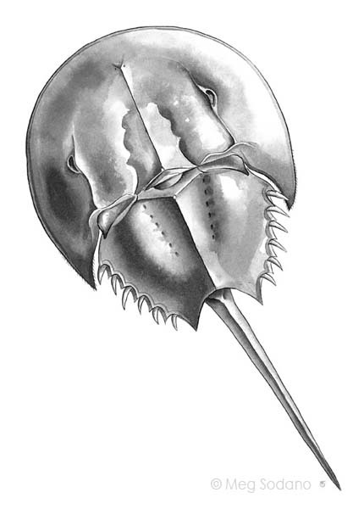
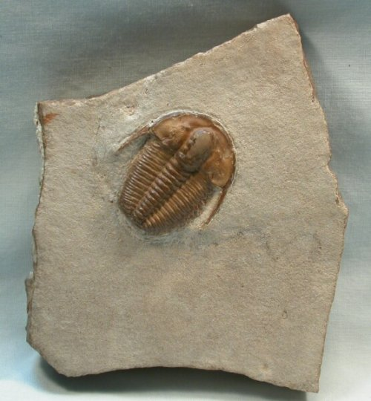
Background: A 16 year old named ______________ was waiting at the bus stop after school. The bus was late and ____________ was bored. ______________ saw a pile of rocks nearby and started playing with them. _______________ noticed that one of the rocks had a strange object on it. Most of the rock was smooth and light brown but on one side it had a dark brown bumpy shape. ____________ wondered if this was a fossil.
Question 1: a) How could _____________ discover if the shape on the rock was a fossil? b) What would a fossil have that a normal rock would not have?
a)
b)
Question 2: _______________ once saw a shell of an organism near the ocean called a horseshoe crab that looks similar to the brown shape on the rock. Could these 2 things be related? Why or why not? Give 2 reasons.
Horseshoe crab
Rock with unidentified object
Yes/No because:
1)
2)

Question 3: If the horseshoe crab really is a descendant (distant relative) of the unidentified organism why does it look so different? Give 3 possible reasons for the variations.
Reason 1:
Reason 2:
Reason 3:
Question 4: In order to decide if the object on the rock really was a living thing at one time what characteristics would it need to have? (Hint: There are 8). Please list them below:
1)
2)
3)

4)
5)

6)

7)

8)
Question 5: When scientists discover fossils of new species they have to make hypotheses to try to explain as much as they can about their discovery. Complete the hypotheses below and explain your thinking with evidence from the articles provided.
Habitat Hypothesis: It lived in ____________________because it has________________________
________________________________________________________________________________
Source:
Food source Hypothesis: It got its food from ____________________because it has___________
________________________________________________________________________________
Source:
Reproduction Hypothesis: It reproduced by having live young/laying eggs/dividing in 2 because it has
__________________________________________________________________________________
Source:
Extinction Hypothesis: This species is no longer alive because ________________________________
__________________________________________________________________________________
Source:
Question 6: Many times scientists still have unanswered questions about a new discovery. Write 2 questions of your own below.
Facts about Horseshoe Crabs
Source: http://myfwc.com/research/saltwater/crustaceans/horseshoe-crabs/facts/
Ancestors of horseshoe crabs date back over 450 million years--long before the age of the dinosaurs.
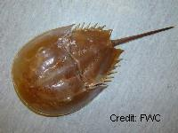
Four species of horseshoe crabs exist today. Only one species, Limulus polyphemus, is found in North America along the Atlantic and Gulf coasts from Maine to Mexico. The other three species are found in Southeast Asia. Horseshoe crabs are not true crabs at all. Horseshoe crabs are more closely related to arachnids (a group that includes spiders and scorpions) than to crustaceans (a group that includes true crabs, lobsters, and shrimp). Horseshoe crabs are often called "living fossils" because fossils of their ancestors date back almost 450 million years--that's 200 million years before dinosaurs existed.
Despite inhabiting the planet for so long, horseshoe crab body forms have changed very little over all of those years.
The strange anatomy of the horseshoe crab is one of this animal's most notable aspects. Unfortunately, the long, thin, spike-like tail of horseshoe crabs has given this species an unfavorable reputation. Many people view horseshoe crabs as dangerous animals because they have sharp tails. In reality, horseshoe crabs are harmless. Their tails are used primarily to flip themselves upright if they are accidentally overturned.
Horseshoe crabs nest on beaches in Florida and mid-Atlantic states.
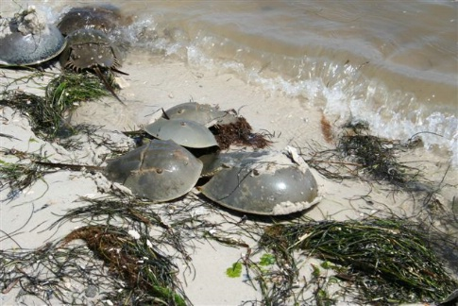
Horseshoe crabs are known for their large nesting aggregations, or groups, on beaches particularly in mid-Atlantic states such as Delaware, New Jersey, and Maryland. These nesting aggregations are commonly observed in Florida as well. During the nesting season, principally in spring and summer, male horseshoe crabs move parallel to the shoreline on sandy flats and intercept females as they pass by. A successful male attaches himself to a female by using his specialized front claws, and together they crawl to the beach. Some males do not attach to females, but still have success in fertilizing the female's eggs. The male fertilizes the eggs as the female lays them in a nest in the sand. Males that do not find mates will often swarm mating couples and try to fertilize some of the females' eggs. Most of this nesting activity takes place during high tides in the three days before and after a new or full moon.
Horseshoe crab larvae emerge from their nests several weeks after the eggs are laid. Juvenile horseshoe crabs resemble adults except that their tails are proportionally smaller. The young and adult horseshoe crabs spend most of their time on the sandy bottoms of intertidal flats or zones above the low tide mark and feed on various invertebrates.

Why are horseshoe crabs important?
Horseshoe crabs are an important part of the ecology of coastal communities. During the nesting season, especially in the mid-Atlantic States, horseshoe crab eggs become the major food source for migrating birds. Over 50 percent of the diet of many shorebird species consists of horseshoe crab eggs. Many bird species in Florida have been observed feeding on horseshoe crab eggs. In addition, many fish species rely on horseshoe crab eggs for food.
Horseshoe crabs are extremely important to the biomedical industry because their unique, copper-based blue blood contains a substance called Limulus amebocyte lysate. The substance, which coagulates in the presence of small amounts of bacterial toxins, is used to test for sterility of medical equipment and virtually all intravenous drugs. Research on the compound eyes of horseshoe crabs has led to a better understanding of human vision. The marine life fishery collects live horseshoe crabs for resale as aquarium, research, or educational specimens, and the American eel and whelk fisheries use horseshoe crabs extensively as bait along many parts of the Atlantic coast.

Threats to horseshoe crabs and research efforts Horseshoe crab numbers are declining throughout much of the species range. Although scientists are unsure of the exact causes of this decline, it is probably due to a variety of factors, including the degradation or decrease of habitat.
In 1998, The Atlantic States Marine Fisheries Commission developed a Horseshoe Crab Fishery Management Plan that requires all Atlantic coastal states to identify horseshoe crab nesting beaches. Currently, with the help of the public, biologists at the Fish and Wildlife Research Institute are trying to document nesting sites of horseshoe crabs throughout the state. If you are interested in becoming more involved with the horseshoe crab survey, please visit the Survey for Horseshoe Crab Nesting Beaches in Florida for more information.
Horseshoe Crab
http://www.enchantedlearning.com/subjects/invertebrates/arthropod/Horseshoecrab.shtml
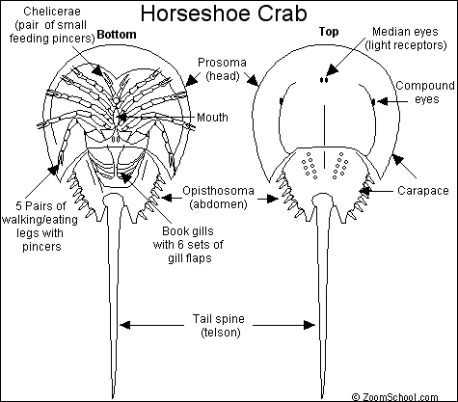
The Horseshoe Crab (also known as the King Crab) is a hard-shelled invertebrate that lives in warm, shallow coastal waters on the sea floor. It is not really a crab; it is more closely related to arachnids (spiders and scorpions). The Horseshoe Crab first appeared about 500 million years ago (during the Ordovician Period), and has changed very little since. There are four species of Horseshoe Crabs alive today; they live off the coasts of India, Japan, Indonesia, the eastern USA, and the Gulf of Mexico.
Diet: The Horseshoe Crab eats sea worms and mollusks (like young clams). They find their prey while walking along the sea bed; they are predominantly nocturnal (most active at night).
Anatomy: The Horseshoe Crab has a hard outer shell (an exoskeleton), 5 pairs of jointed legs and a pair of pincers. The Horseshoe Crab is up to 2 ft (60 cm) long and weighs up to 10 pounds (4.5 kg); it molts its skin many times as it grows. The male is two-thirds the size of the female. The long tail is not a weapon; it is used as a rudder (for steering) and for righting itself when it is flipped upside down. The Horseshoe Crab has light blue, copper-based blood. It breathes using book gills, thin plates located on the abdomen.
Reproduction: Horseshoe Crabs hatch from eggs that the female lays. She lays roughly 20,000 small, green eggs in holes that she digs in the sand on the beach.
Classification: Phylum Arthropoda, Class Merostomata, Order Xiphosura, Genus and species Limulus polyphemus, Tachypleus tridentatus, T. gigas, and Carcinoscorpinus rotundicauda.

