Structures | Functions
1.
2.
3.
4.
5.
6.
7.
8.
9.
10.
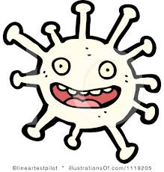
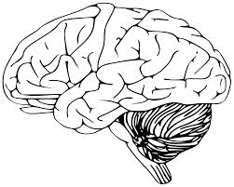
Cell Design Challenge
Help! A new virus has been discovered that can take control of our brains! As a neuroscientist it is your job to find a way to modify (change) our cells to protect them against the virus attack.
Directions: You will design, build and describe a model of a neuron cell that has special structures that will protect it from the virus. Use a different color for each structure.
Step 1: Draw the cell that you will build. Label at least 7 structures and record their functions below. Use your analogy chart and the Cell Unit Review to help you.
Step 2: List the materials you will need to build your model. (Use recycled items, we have $0!)
_______________________________________________________________
Step 3: Questions about your cell.
Labeled drawing of your cell:

1) Is it eukaryotic or prokaryotic? How do you know? Why did you choose this?
It’s _________________________ because it has a _________________________. I chose this type of cell because
__________________________________________________________________.
2) How does it communicate with other cells to let them know the virus is coming?
It sends _______________________ through the _______________________________ to the other cells.
3) What is on the outside of the cell to protect it from the virus attack?
It has _________________________ and _________________________ that will stop the virus from entering quickly.
4) Can your cell move by itself? Why or why not?
Yes it can move/no it can’t move because _____________________________________________________.
5) What other special characteristics does your cell have that a normal neuron does not? Why?
It has _____________________________ so it can ________________________________________________________ and it has
____________________________________so it can ________________________________________________________.
6) Where is your cell located? (Use the biology book to help you).
Name the tissue:
Name the organ:
Name the organ system:
7) How will you know if your cell is dead? What will you see?
If the virus kills my cell it will _________________________________ and stop
__________________________________.

