Cell Division, Mitosis and Cancer Article
Source: http://www.abpischools.org.uk/page/modules/celldiv_cancer/cancer4.cfm
Before you read:

1) What is Mitosis?
2) Why is Mitosis important?
3) Is Mitosis similar to regeneration? How?
While you read:
1) Actively read the article and underline important information. (At least 2x per paragraph)
2) Write 1 opinion and 1 question about the article below:
I think this article is _______________ because_______________________________________.
A question I have is______________________________________________________________?
3) What are 3 reasons cells need to need to replicate (copy) themselves? Paragraph #_____
Reason 1:

Reason 2:

Reason 3:
4) When one parent cell divides how many daughter cells are made? Paragraph #_________
5) How are cancer cells different than normal cells? Paragraph #________
They don’t have ____________________that normal cells have.
6) Why are there different types of treatment for cancer? Paragraph #_______
7) What is a mutation and what does it cause? Paragraph #_______
8) How do some children get mutated genes? Paragraph #_______
9) What can genetic tests tell you? Paragraph #_______
After you read:
Respond to this question- Would you have a genetic test done? Why or why not?
Cell Division, Cancer and Mitosis
Source: http://www.abpischools.org.uk/page/modules/celldiv_cancer/cancer4.cfm
(1) Multi cellular organisms, like humans, are made up of billions of cells. These cells need to divide and copy themselves for a variety of reasons. For example:
- -cells wear out and need to be replaced
- -new cells allow the body to repair damaged tissue
- -new cells allow the body to grow
Mitosis
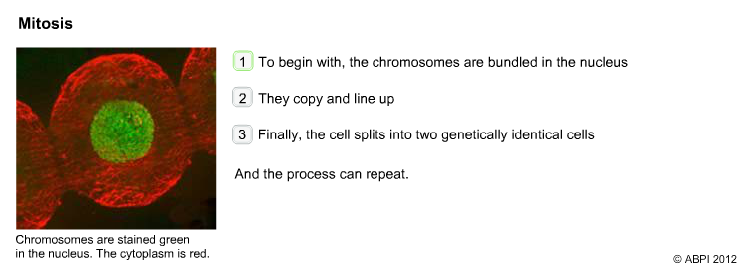
(2)The most common form of cell division is called mitosis. It is used for growth and repair. During mitosis, a cell makes an exact copy of itself and splits into two new cells. Each cell contains an exact copy of the original cell's chromosomes in their 23 pairs. This is the reason why all the cells in an organism are genetically identical.
Cancer: mitosis out of control
(3) Mitosis is closely controlled by the genes inside every cell. Sometimes this control can go wrong. If that happens in just a single cell, it can replicate itself to make new cells that are also out of control. These are cancer cells. They continue to replicate rapidly without the control systems that normal cells have. Cancer cells will form lumps, or tumours, that damage the surrounding tissues. Sometimes, cancer cells break off from the original tumour and spread in the blood to other parts of the body. When a tumour spreads to another part of the body it is said to have metastasized. They continue to replicate and make more tumours. These are called secondary tumours.
Medicines that are used to treat cancer are sometimes aimed at killing cells that are rapidly dividing by mitosis. They inhibit the synthesis or function of DNA - this type of treatment is called chemotherapy. More modern medicines target specific cancers in different ways. Many inhibit the growth signals for that type of cell.
Fighting cancer: stopping tumour cells from growing
(4) There are many different types of cancer. They depend on which type of cell was the original one that started to replicate out of control. This means that there is not just one treatment for cancer. Treatments may include a combination of surgery, medicines and radiation therapy (radiotherapy).
As researchers have come to understand more about cancers, new and targeted therapies are constantly being developed. For example, a type of breast cancer that is influenced by the hormone oestrogen can be treated with hormone therapy that blocks the action or synthesis of oestrogen. Other medicines can block growth signals to the cancer cell and so slow the development of a tumour or block the growth of new blood vessels into tumours. This effectively 'starves' the cancer cells of the nutrients they need to grow.
Gene Mutations and Cancer
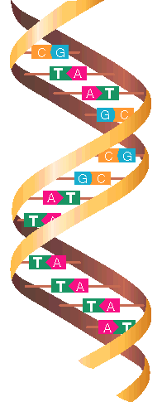
(5)The information in DNA is carried in the sequence of bases. Changes, or mutations, in just one or two bases can scramble the information and mean that the gene does not work properly. If this mutation is in a gene that controls cell division it can trigger the uncontrolled replication of that cell. This faulty gene is copied to all the new cells and so the uncontrolled growth continues. The cells form a tumour.
Cancers linked to known genetic markers
(6) Cancer is quite rare, especially in people under the age of 60. However, some cancers appear to 'run in families'. Researchers have found that certain mutated genes, passed from parents to their children, can dramatically increase the chance of developing a particular cancer. Inheriting the faulty gene does not guarantee that the person will develop cancer but it appears to increase the chance that they will.
Genetic tests can be made to see if a person has inherited a mutated gene that makes them more likely to develop cancer. Some genes, such as P53, are associated with a range of types of cancer, others are specific to just one type.
Cancer | Examples of genes associated with specific cancers:
Breast cancer | BRCA1, BRCA2
Ovarian cancer | BRCA1, BRCA2
Prostate cancer | BRCA2, HPC1, HPC2, HPCX
Melanoma (skin cancer) | CDKN2A, MITF
Stomach | CDH1 (E-cadherin)
Bowel cancer | MSH2, MSH6, MLH1, APC
Using the information
(7)There are ethical issues around genetic screening. The results can tell a person if they are at a higher than normal risk of developing cancer, but what should be done with this information?
Would you want to know that you were at high risk? What would you do if you did know? How would you react if you were clear of any mutated genes? How should doctors handle this information? Should doctors screen for cancers that cannot be cured?
What decisions would you make? How would you help someone thinking about having a genetic test decide what to do?

