Layout Editor Test Directions: Arrange the 7 articles in a neat, easy to read format. Remember fonts and headlines should be similar size and type of writing. Each section should have a picture. It is expensive to print on many pages so you should try to use as few pages as possible. When you are done put your name on the top and email it to Mrs. Hutchison at khutchison@usd116.org as an attachment. Good luck!

Skateboarding
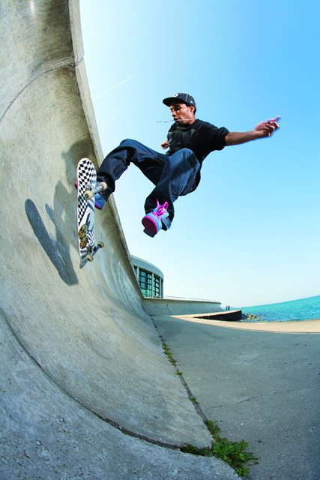
First you start with getting a skateboard then some pads and a helmet. Then you push yourself and then try to stay on your balance. You go skateboarding in a skate park so you can practice. You need a flat and smooth place to skate at and to go faster. If you are done practicing you can now practice some trick or something else. Like turning around with it and flipping it to know how good you are. When you are done go to the skate park and use the ramps but remember to use a helmet and some pads. I use a helmet so I can`t hurt my head. The most important to protect is you head and your elbows so you can`t break a bone. And that’s how you skateboard.

skateboardingtricksforbeginners.com

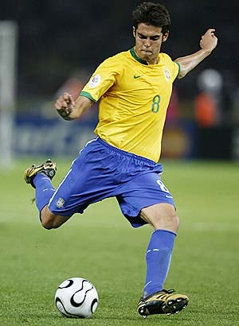
Date: March/ 27th / 2012
Urbana High School Sports
There are many sports in Urbana like: soccer, football, volleyball, tennis, etc. But the game I like the most is soccer, because I played soccer all my life. To play soccer you will need 11 people in each team, you will run with the ball, you need to pass the ball, and the most important is every team needs to score to win. The team with the most goals is the winner.
Soccer with Kaka Soccer with Messi
Kaka http://www.fansfc.com/players/2891.html
Messi
http://www.guardian.co.uk/football/2011/apr/15/johan-cruyff-lionel-messi-cristiano-ronaldo
Travel of East Asia
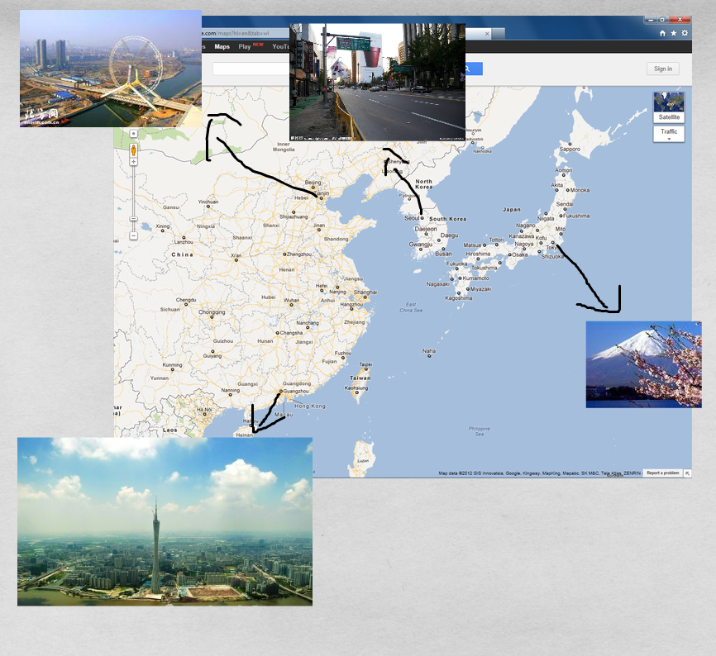
Tianjin: The 3rd biggest city in China. It’s very close to the capital city, Beijing.
Guangzhou: It’s very close to Hong-Kong. An economy center of south China.
Seoul: The capital city of South Korea.
Tokyo: The capital and the biggest city in Japan.

If you think you are a good student in Mrs. Hutchison’s class room, you should be following these next steps:
First: Always follow R.O.A.R:
This means;
- Be Respectful
- Be On –Task
- Have A Good Attitude
- Be Responsible

RESPECT
- Do not talk when someone else is talking.
- Be respectful to others.
- Don’t say inappropriate words.

ON_TASK
- Do work in class.
- Do Homework.
- Do Whatever Mrs. Hutchison says.
- Follow instructions .

HAVE A GOOD ATTITUDE
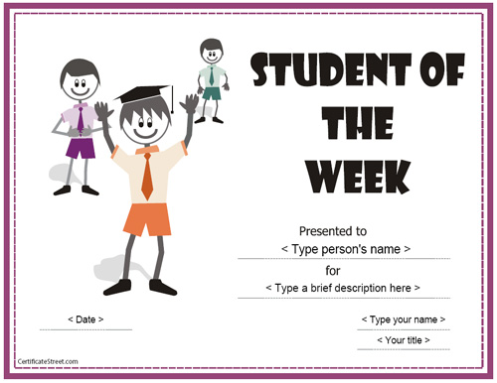
- Be positive
- Do not argue
- Be compliant. (follow instructions)
- Do not complain.
- Don’t be annoying.

BE RESPONSIBLE
- Do Homework.
- Bring supplies.
- Be on time.
- Return things you borrow.
- Be responsible with your actions
Surch; google – picture.

Calendar schedule
3/15 - Open gym at 6:30-8:00pm
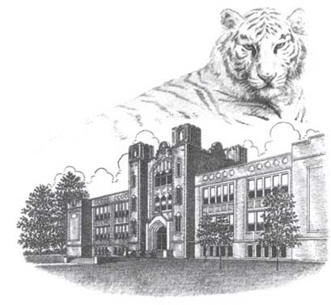
3/16 - Multicultural club meeting at 3:30-4:30pm
see more: https://www.facebook.com/pages/UHS-Multicultural-Club/182947301807508
3/19 - Spring break begins
3-25 – The last day of spring break
3/26 – First day after spring break and the first day of Mrs. Hutchison’s art class at 4:30-5:30pm
4/6 – No school board holiday
(UHS Website http://www.usd116.org/uhs/calendar.htm)
After school programs
Mondays: Hands on Hanji / Ms. Hutchison / 4:30-5:30pm
Mon-Thurs: Homework Lab / Tutors / 3:30-5:30pm
Wednesdays: International food / Ms. Amanda Perez / 3:30-5:30pm
Tuesdays: Yoga Basics / Ms. Christine Creek / 3:30-5:00pm
(21st community learning center for UHS http://www.usd116.org/uhs/events/clc-2012.htm)
This is a picture of Urbana HS and we’re the tiger.

Mercedes Benz Car.
Web: http://.mbusa.com/mercedes/index
Info: Mercedes Benz 2013 Sl-Class Roadster
- This is a fast car.
- The horse power is 429 (really fast)
- Acceleration 4.5sec 0-60. This means the car is fast.
- The cost starts at $ 105,500
- This a sport car
- You can even use your computer or smartphone to unlock your car to lock it and to turn it on you just need to connect with the application mbrace
- This car is safe to drive because it has the air protection in case of a car accident that can be located in front of the car and in the back .
- World Languages
- IN MY ESL CLASS WE HAVE VERY DIVERSE PEOPLE THAT SPEAK DIFFERENT LANGUAGES. HERE ARE SOME EXAMPLES:
English | Spanish | Chinese | French | Laos
Rain | Lluvia | (YU) | Pluie | Fon tok
Mountain | Montaña | (SHAN) | Montagne | Phou
People | Personas | (REN) | Personne | Khon
Friends | Amigos | (PENG YOU) | Amie | Mou
Thank you | Gracias | (XIE XIE) | Merci | Khop jai

- HTTP://TRANSLATE.GOOGLE.COM

