from THROUGH A GLASS DARKLY by Fred H. Cate

Active readers annotate as they read. As we're reading this article, you should interact with the text at least 3 times.

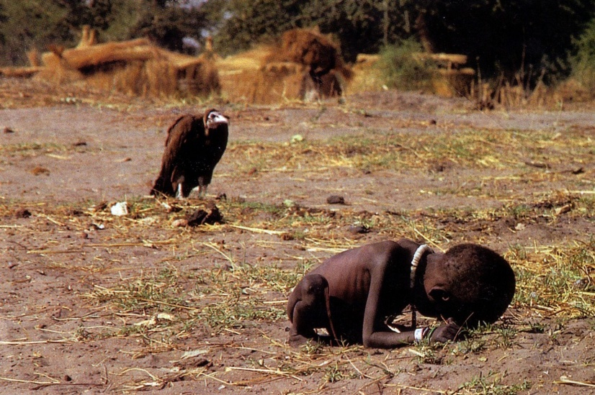
The image is stark and horrific. A vulture stands calmly in the background, peering over a small child who is bent double on the parched earth. The child’s head, bowed to the ground so that the face is invisible, dwarfs the emaciated body. Tiny hands clutch at tufts of straw. Incongruously, although the child is naked, it wears a string of heavy flat beads around its neck and bracelets around its one visible wrist. The scene is one of utter despair as the vulture waits for the child to die.

The photograph first appeared on March 26, 1993, in the New York Times, along with an article about the government of Sudan and its response to the famine that threatened a million Sudanese. The caption read: "In a move meant to placate the West, the Sudanese Government is opening parts of the country’s famine-stricken south to relief operations, but for some, it could be too late. A little girl, weakened from hunger, collapsed recently along the trail to a feeding center in Ayod. Nearby, a vulture waited."² Neither the article nor the caption mentioned the fate of the girl.
Letters and phone calls poured into the New York Times. Four days after the original photograph ran, the Times took the unusual step of publishing an editor’s note about the fate of the girl in the picture. "The photographer reports," the Times’ editors wrote, "that she recovered enough to resume her trek after the vulture was chased away. It is not known," the note concluded chillingly, "whether she reached the center."³
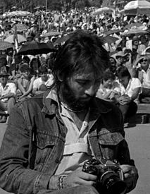
The following week, Time published the photograph in color. The picture appeared on its own with this brief caption: "IN EXTREMIS: A million Sudanese face starvation. Here a child falters en route to a feeding center, while a vulture hovers."⁴ Before the month was out, Time, too, had been forced to print a response to the flood of correspondence the magazine had received. Some readers criticized the picture; others lauded its poignancy and power. But virtually everyone who wrote or called wanted to know one thing: what happened to the child? Time offered this pale answer: "[The photographer] is not sure what happened to the little girl, who was moving toward the nearby relief center when he saw her, but he is hopeful that she received food and treatment."⁵
The photographer was Kevin Carter, a 32-year-old photojournalist for the Johannesburg Weekly Mail, who had borrowed money to travel to Sudan as a free-lancer earlier in March. As the popularity and controversy surrounding his photograph grew, Carter found himself explaining repeatedly the circumstances in which he took it.
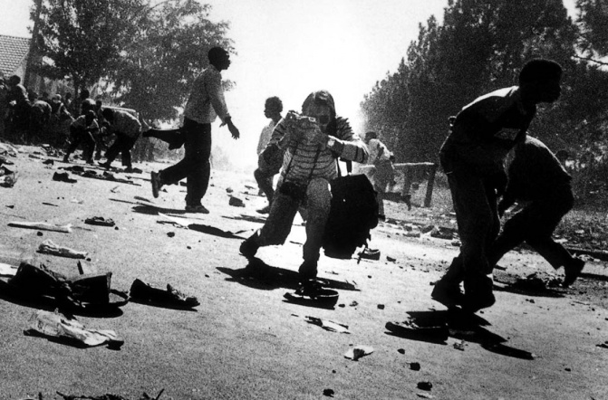
Soon after his plane had touched down near the village of Ayod, Carter had sought refuge from the sight of thousands of people starving to death. He wandered into the open bush, where he heard a soft, high-pitched whimpering. Following the noise, he found the tiny girl, trying to make her way to the feeding center. As he crouched to take his picture, a vulture landed nearby. He waited quietly, not wanting to disturb the vulture and hoping that it would spread its wings for an even more dramatic image. When after 20 minutes it had not, Carter took his picture, chased the vulture away, and watched the girl resume her struggle. Afterward, Carter reported, he sat under a tree, smoked a cigarette, talked to God, and cried.⁶ He longed to hug his young daughter Megan. "I alone could never have helped all of them," Carter’s parents report he later told them. "I sat crying under a tree for a long time."⁷
The picture became, as Time later called it, an "icon of Africa’s anguish."⁸ It appeared in hundreds of newspapers and magazines around the world. Relief organizations used it in their literature; Amnesty International featured it on a poster. That single picture, James Fallows writes, "did more than any other news story" to draw attention to the horrendous drought and ensuing famine that was wracking Sudan.⁹ On May 23, 1994, the shot earned Kevin Carter the Pulitzer Prize for feature photography.
But the photograph also provoked a maelstrom of public, journalistic, and academic debate about Carter’s failure to help the little girl. Outraged readers wrote letters to newspapers calling Carter the "true vulture" and "devoid of humanity," and condemning his failure to act as "inexcusable," "inhuman," and "uncaring." Others defended Carter’s action, noting the magnitude of the crisis facing Sudan and the creed of journalists to not get involved in the stories they report. "Carter did what he was there to do and in doing so documented his own humanity. . . . By being himself and doing his job, he recorded a haunting image that brought attention to the starving in Sudan."¹⁰ "That image is captured for eternity," said Bob Steele, director of the ethics program at the Poynter Institute for Media Studies. "There were, ideally, lots of other people to give aid, medicines, care, but nobody is going to replace the role of the journalist. The military, the aid workers, the Red Cross--no one filled the role Kevin Carter did. He was the one who got the message out to the rest of the world."¹¹
One reader wrote to the St. Petersburg Times, which had carried the picture on its front page that "it appears that Kevin Carter did his job well as a photographer, but on a scale of 1 to 10, his humanness ranks as a -10." The letter continued:
"The article indicates the child collapsed outside of a 'nearby relief center.' Obviously, nearby was too far for this child but was near enough for Kevin Carter to see her when he emerged from the relief center. He then positions his camera and takes some photographs of the child and then what? Walks back into the relief center and forgets about her? How? How could anyone forget about her?"
Kevin Carter did not, in fact, forget about that little girl on the outskirts of Ayod. "This is the ghastly image of what is happening to thousands of children," Time quoted him as saying. "Southern Sudan is hell on earth, and the experience was the most horrifying of my career."¹³ He later told his friend and journalist Chris Marais, "I’m really, really sorry I didn’t pick the child up."¹⁴
Carter’s pain and the criticism following publication of the photograph and again after the awarding of the Pulitzer, accentuated by problems in his personal life and drug abuse, were more than he could stand. Two months after standing in the classical rotunda of Columbia University’s Low Memorial Library to receive the Pulitzer Prize, Carter parked his pick-up truck in a park in a Johannesburg suburb where he had played as a child, ran a hose from the tailpipe into the cab, and killed himself.
A note found next to him the following morning read: "I am haunted by the vivid memories of killings and corpses and anger and pain . . . of starving or wounded children, of trigger-happy madmen, often police, of killer executioners. . . The pain of life overrides the joy, to the point that joy does not exist."¹⁵
The "Starving Sudanese Child," as the picture is called, is more than just a tragic illustration of drought and famine in Sudan, a little girl whose suffering was ignored, or the roller coaster life and premature death of a talented photojournalist. It highlights many of the critical issues posed by media coverage of humanitarian emergencies: the powerful--if often numbing or distorting--impact of images of devastation and suffering; the complicated relationships among relief organizations, the public, policymakers, and the media; the risks and costs to journalists of all forms of covering humanitarian crises; the desperate need to improve communication about, and understanding of, significant events and developments, especially in distant places; and the array of forces that make achieving that goal so difficult.

***Turn to the next page to complete the reading questions.

Reading Questions:
1. This article describes competing perspectives about the role on the conflict triangle this journalist, Kevin Carter, played. Explain his role, from two different perspectives, and then provide relevant textual evidence that demonstrates that perspective.
Perspective 1  Carter was a …  (choose from bystander, rescuer, victim, or perpetrator) | Perspective 2  Carter was a …  (choose from bystander, rescuer, victim, or perpetrator)
Cited textual evidence to support that perspective: | Cited textual evidence to support that perspective:
Why is this evidence relevant? How does it prove this perspective? | Why is this evidence relevant? How does it prove this perspective?

2. What is YOUR perspective on this issue? What role on the conflict triangle did Carter play? Explain your position thoroughly, using cited textual evidence and your opinions as support.

