*Before 1933*

World War I (1914–1918) devastated Europe and created new countries. The years that followed saw the continent struggle to recover from the death or injury of tens of millions of soldiers and civilians, as well as catastrophic damage to property and industry. In 1933, over 9 million Jews lived in Europe (1.7% of the total population)—working and raising families in the harsh reality of the worldwide economic depression. German Jews numbered about 500,000 or less than 1% of the national population.

*1942–1945*

In a period marked by intense fighting on both the eastern and western fronts of World War II, Nazi Germany also intensified its pursuit of the “Final Solution.” These years saw systematic deportations of millions of Jews to increasingly efficient killing centers using poison gas. By the end of the war in spring 1945, as the Germans and their Axis partners were pushed back on both fronts, Allied troops uncovered the full extent of crimes committed during the Holocaust.

*1933–1938*

Following the appointment of Adolf Hitler as German chancellor on January 30, 1933, the Nazi state (also referred to as the Third Reich) quickly became a regime in which citizens had no guaranteed basic rights. The Nazi rise to power brought an end to the Weimar Republic, the German parliamentary democracy established after World War I.  In 1933, the regime established the first concentration camps, imprisoning its political opponents, homosexuals, Jehovah’s Witnesses, and others classified as “dangerous.”  Extensive propaganda was used to spread the Nazi Party’s racist goals and ideals. During the first six years of Hitler’s dictatorship, German Jews felt the effects of more than 400 decrees and regulations that restricted all aspects of their public and private lives.

*After 1945*

By May 1945, the Germans and their collaborators had murdered six million European Jews as part of a systematic plan of genocide—the Holocaust. When Allied troops entered the concentration camps, they discovered piles of corpses, bones, and human ashes—testimony to Nazi mass murder. Soldiers also found thousands of survivors—Jews and non-Jews—suffering from starvation and disease. For survivors, the prospect of rebuilding their lives was daunting. With few possibilities for emigration, tens of thousands of homeless Holocaust survivors were housed in displaced persons (DP) camps. In the following years, many international and domestic courts conducted trials of accused war criminals.

*1939–1941*

The Holocaust took place in the broader context of World War II. On September 1, 1939, Germany invaded Poland. Over the next year, Nazi Germany and its allies conquered much of Europe. German officials confiscated Jewish property, in many places required Jews to wear identifying armbands, and established ghettos and forced-labor camps. In June 1941, Germany turned on its ally, the Soviet Union. Often drawing on local civilian and police support, Einsatzgruppen (mobile killing units) followed the German army and carried out mass shootings as it advanced into Soviet lands. Gas vans also appeared on the eastern front in late fall 1941.

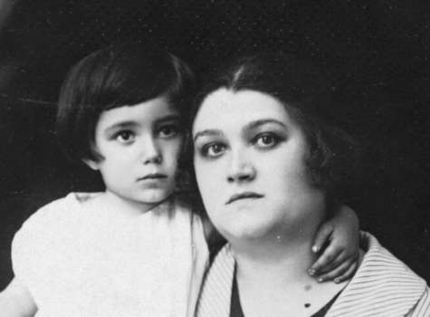

Studio portrait of Zeni Farbenblum and her son, Rudy, in Mukachevo, Czechoslovakia. —*US Holocaust Memorial Museum, courtesy of Jaine Farbenblum Shattan*



Studio portrait of Zeni Farbenblum and her son, Rudy, in Mukachevo, Czechoslovakia. —*US Holocaust Memorial Museum, courtesy of Jaine Farbenblum Shattan*

Hitler reviews an SA parade as it passes in front of the Dortmund theater. —*Mahn- und Gedenkstaette Steinwache Dortmund*

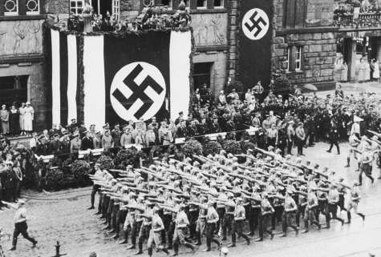

Hitler reviews an SA parade as it passes in front of the Dortmund theater. —*Mahn- und Gedenkstaette Steinwache Dortmund*



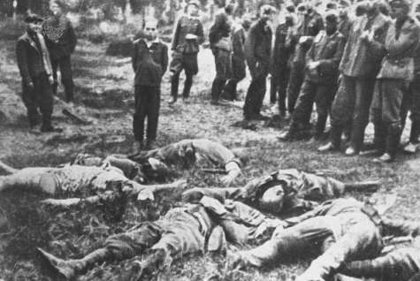

Members of an *Einsatzgruppe* (mobile killing squad) before shooting a Jewish youth. —*US Holocaust Memorial Museum, courtesy of Dokumentationsarchiv des Oesterreichischen Widerstandes*

Members of an *Einsatzgruppe* (mobile killing squad) before shooting a Jewish youth. —*US Holocaust Memorial Museum, courtesy of Dokumentationsarchiv des Oesterreichischen Widerstandes*

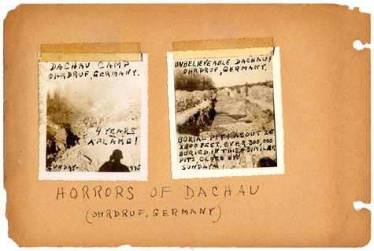

Album documenting the liberation of the Ohrdruf camp, a subcamp of Buchenwald (mislabeled as Dachau). Ohrdruf, Germany, April 1, 1945. —*US Holocaust Memorial Museum, courtesy of Raymond Malenfant*



Album documenting the liberation of the Ohrdruf camp, a subcamp of Buchenwald (mislabeled as Dachau). Ohrdruf, Germany, April 1, 1945. —*US Holocaust Memorial Museum, courtesy of Raymond Malenfant*

A group of young survivors in Buchenwald. —*US Holocaust Memorial Museum, courtesy of Hadassah Bimko Rosensaft*

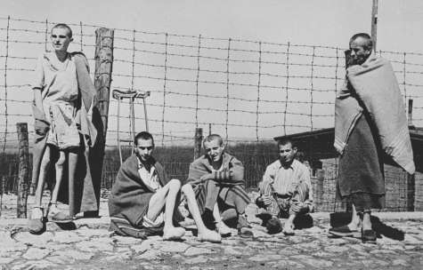

A group of young survivors in Buchenwald. —*US Holocaust Memorial Museum, courtesy of Hadassah Bimko Rosensaft*

