Introduction to Neurons
Part 1: Intro to Neurons

What are they? | What do they do? | Where can we find them? | Why are they important? | How do they function? | When are they in danger?

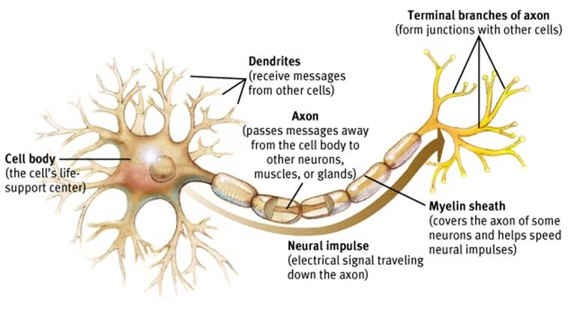
Part 2: Label the parts of the neuron below. Identify the nucleus, cell membrane and cytoplasm.

Part 3: Are zombies real? Watch the video and answer the questions below.
- What could make us become “zombies”?
- How would the virus get inside our brains?
- What would the virus make us do? List 4 things.
- Do zombies currently exist in nature? Give an example below.

