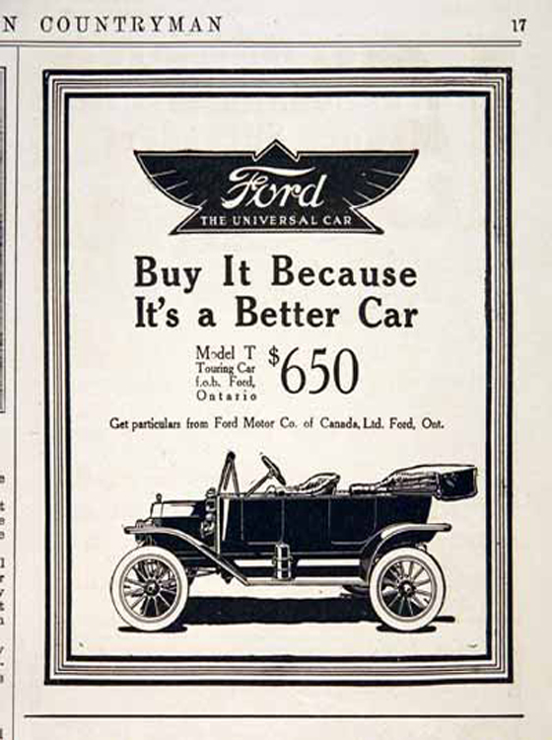

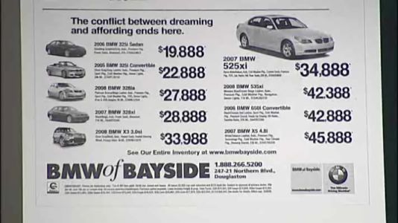

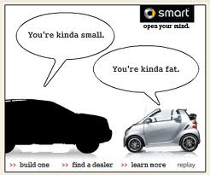

Link for Creative Car Ads:
http://www.webdesignfact.com/2012/04/creative-car-advertisements.html

This ad shows a small smart car and a big car.

The claim is that the smart car is small and the big car is fat.
The evidence is the picture shows the smart car is smaller than the black car.

