Name______________________________ Date___________________ Class____________________

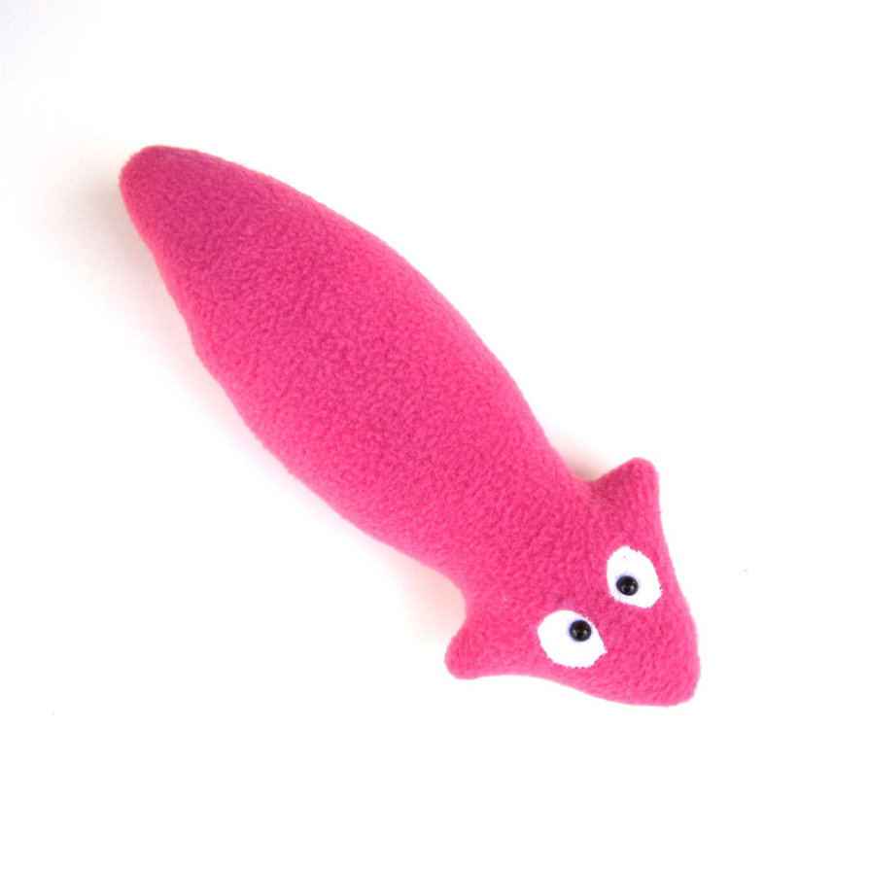
Meet Planarian Paolo
Part 1: Planarian Visualization- Use information from the story to summarize what’s happening to Paolo in the lab.
(1) It’s an early morning at the local high school. Planarian Paolo senses that it is going to be a good day; he was just fed a few days ago and he is content with swimming in the plastic container his caretakers placed him in.
(2)As the students file into the classroom, the teacher begins to speak about “cutting” and “using proper technique” when using a coverslip. Paolo has no idea what these words mean, mostly because he doesn’t have ears!
(3) One group of students, two boys and two girls, pick Paolo up with a plastic pipette and place him on a very cold, icy surface. The frigid temperature against Paolo’s body causes him to slow down and stretch out—he is not a fan of swimming when it is so cold!
(4) The students begin cutting Paolo into separate pieces. Paolo is worried! What will happen to him??
(1) | (2)
Caption: | Caption:
(3) | (4)
Caption: | Caption:
Part 2-Your goal: Explain to Paolo that he doesn’t need to worry because he is a Planarian! Describe what makes him different from other organisms and explain what’s happening inside his body. Underline the vocabulary words that you use.

