How do we perceive color?

You need to know that color is not a physical thing. While light itself is a physical thing, color is a perception. Color is the way our brains process information about a combination of the wavelengths of light, which makes colors. Below are the wavelengths of light humans perceive (See Figure 1) - known as the human visual spectrum:

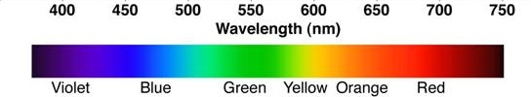
Figure 1

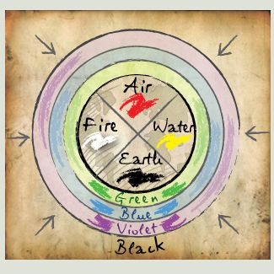
Figure 2

In Ancient Greece, Aristotle developed the first known theory of color. According to Aristotle, God sent down color from the heavens as “celestial rays”. Aristotle identified four main colors, which corresponded to the four elements of the earth (See Figure 2): Air/Wind (red), Fire (white), Water (yellow), Earth (black).

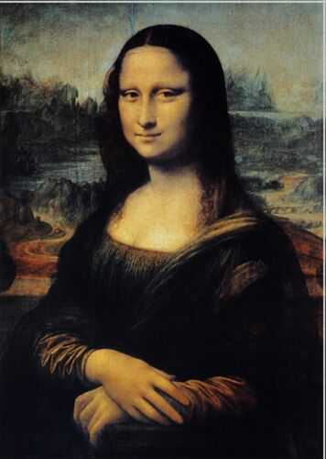
Not the same as what you learn in art class:
Figure 3
In his Treatise on Painting, Leonardo da Vinci suggested an alternative hierarchy of color for the first time (See Figure 3). He listed six colors in the following order: white, yellow (earth), green (water), blue (air), red (fire), and black. He said that while philosophers viewed white as the "cause, or the receiver" of colors and black as the absence of color, both were essential to the painter, with white representing light, and black, darkness.
What color do we see when red and green light are mixed? You are mistaken if a muddy brown color is what you picture! A combination of red and green light makes yellow. Perception of combinations of different lights is absolutely different from what you get when you mix different colors of paint. The reason for this mismatch relates to how color information carried by light gets to the eye.
Did you know that a computer screen has only red, green and blue dots?

For mixing light, color combination goes directly to the eye. For paints, light is either absorbed or reflected and the reflected light is transmitted to the eye; the combination of reflected colors creates specific colors.

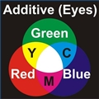
The light-sensing cells in the eye that detect color are cone cells. Cones come in three varieties: red-sensitive, green-sensitive and blue-sensitive. We perceive yellow when the red and green cones are activated. The activation of more than one type of cone is necessary for perception of most colors. When red and green lights activate the retina, yellow is perceived; when green and blue, cyan is perceived and blue and red, magenta is perceived. Thus, detecting different colors of light is through an additive process or system (See Figure 4). On the other hand, paint derives its color by absorbing light, leaving the remaining colors for detection by our eyes. Thus, the perception of paint colors occurs through a subtractive process or system (See Figure 5).
Figure 4

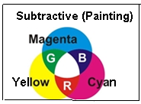
The mystery behind “white”:
Figure 5
White light is composed of all the colors of the visible spectrum (see the color wheel Figure 5). White paint looks white in sunlight because it absorbs none and reflects all the colors of light. Under blue light, it appears blue. Under green light, it appears green. Under yellow light it appears yellow, and so forth. Under white lighting, a yellow object would appear “yellow” because red and green wavelengths of light are reflected into the eye, activating the “red” and “green” cone cells simultaneously. On the other hand, at the same time, “blue” is absorbed by the yellow object, therefore “blue” cone cells are not activated.

Is it this simple?
Many people assume that color is a defining property of objects and it is based entirely on specific wavelengths of light reflected from them. But color sensation is created in the brain. Imagine if the colors we perceive depended only on the wavelength of reflected light. In that case, the color of your t-shirt would appear to change dramatically with variations in lighting throughout the day and in shadows! Instead, patterns of activity in your brain lead to perception of the color of your t-shirt that is relatively stable regardless of changes in the environment.
This does not mean that environment, context, or experience has no role in perception of colors.

Role of experience: From our experience, when we see one side darker, we see that one face of this cube is in shadow and our vision system tries to compensate for it.
Role of context: It was discovered in the early 1800s that a color looks lighter if the surrounding area is darker; a bright color looks darker if the surrounding area is lighter. This simple rule is also called the “simultaneous contrast” illustrated in Figure 7 (below).

Figure 7
Simultaneous Contrast 1

References:
Livingstone, M. (2002). Vision and Art: The Biology of Seeing. New York, NY: Abrams.
Gregory, R.L. (1997) Eye and Brain: the psychology of seeing (5th ed.). Princeton, NJ: Princeton University Press.
Web Exhibits: An interactive museum. Retrieved from http://www.webexhibits.org/ Retrieved on 07.09.2010.
Purves, D., Lotto, R. B. (2003). Why We See What We Do? : An empirical theory of vision. Sunderland, MA: Sinauer.

Images:
Figure 1 &2: Web Exhibits: An interactive museum. Retrieved from http://www.webexhibits.org/ Retrieved on 07.09.2010.
Figure 3: http://www.freewebs.com/uitwisselingsprojectmerewade/art.htm on 07.09.2010 Retrieved on 07.09.2010
Figure 4 & 5: http://www.pcbdesign007.com/pages/zone.cgi?a=49039&_pf_=1 Retrieved on 07.09.2010
Figure 6: http://www.softexpressions.com/software/books/4L0070.php Retrieved on 07.09.2010
Figure 7: http://www.brown.edu/Courses/CG11/2005/Group161/SimultaneousColorContrast.htm Retrieved on 07.09.2010

