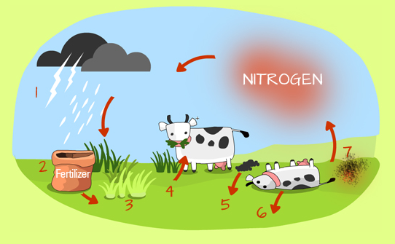
Description of the Nitrogen Cycle
Directions: a)Underline the important words.
b) Summarize each step in 10 words or less and complete your Nitrogen cycle notes.
c) Verify (check) your work with a partner.

1. Nitrogen is introduced to the soil by precipitation (rain, lightning).
2. Nitrates don’t only come from Nitrogen in the air. They can also be obtained by the conversion of ammonia (NH₃), commonly used in fertilizers by nitrifying bacteria in the soil. Some root nodules can also convert nitrogen in the soil into nitrates (NO₃).
3. Plants build up proteins using nitrates (NO₃) absorbed from the soil.
4. When animals like cows, eat these plants, they in turn use nitrogen to build animal protein.
5-6. When these animals (cows) poop, pee or die, the urea, excreta or carcass are broken down by decomposers and the nitrogen is re-introduced into the soil in the form of ammonia (NH₃)
7. Nitrates (NO₃) in the soil can also be broken down by denitrifying bacteria (in specific conditions) and sent into the air as nitrogen. This process can help make the soil infertile, because it will lack the nitrates (NO₃) needed for plant use.
Once nitrogen gets back into the air, the cycle continues.

