Redi’s Fly Experiment
Long ago, in the 1600's people thought that living things could come from nonliving things. Have you ever seen flies flying around your food?

Well some people thought that the flies actually came from the food. Since maggots (the baby flies) could often be found on old (rotting) meat, many people, back then, thought that the maggots actually came from the old meat.
Francesco Redi, an Italian scientist, didn't believe this.
He thought that living things could ONLY come from other living things. And since the old meat was not living, it couldn't make maggots.
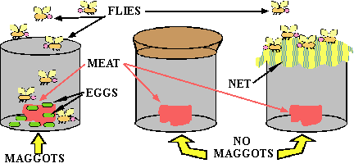
Redi set up an experiment to test his hypothesis. He took three jars. In each jar he placed a piece of old meat. He left one jar open. The second jar he closed tightly with a lid. Then he put a thin net over the third jar.
After a few days, Redi saw that maggots were only in the jar that was completely left open. He concluded that the maggots were only in the jar that was left open because the flies were able to land on the open meat in the open jar and lay eggs. No maggots were found on the meat that the flies couldn't directly touch. This experiment helped prove that living things come only from other living things.

Adapted from: http://mrsdlovesscience.com/lifeliving.html
Name________________________________ Date_______________Class____________________
Scientific Method Quiz

1.)What model organism did Redi study? Draw a picture of it and write its name.
2.) List 4 materials that Redi used.
3.) Write 3 observations about the jars in Redi’s experiment.
It appears that Jar 1 has :

_____________________________________________________________________
It appears that Jar 2 has :

_____________________________________________________________________
It appears that Jar 3 has:

_____________________________________________________________________
4.) Compare the 3 jars.
5.) Contrast the 3 jars.

6.) What was Redi’s hypothesis? Write it below.

7.) Using the story, write a 5 step Procedure for Redi’s experiment.
1.

2.

3.

4.

5.
8.) After you read paragraph 5 from the story, record the experiment results in a data table.
Data Table
What does this column show?  Label=_________ | What does this column show?  Label=_________________________________________________
1
2
3

9.) Analyze the results: Why are there maggots (baby flies) in Jar 1 but there are no flies in Jar 2 or Jar 3? Explain your answer.

10.) (a)What was Redi’s conclusion?
(b) Was Redi’s hypothesis correct or incorrect? Why?

11.) If you did this experiment, what could you do differently? Why?
12.) How did Redi use the scientific method? Describe 3 or more parts that he used.
13.) How do you think you did on this quiz? Why?

