Name____________________________________ Date____________________ Class_________________
Student Self-Advocacy Practice #1
Goals: 1) Define advocate
2) Advocate for yourself to your teachers in an email
Part 1: Complete the vocabulary box for the word advocate

Part of Speech (and explain how you know): | Definition
Examples of people who advocate (3 or more) and what they advocate for : | Example sentence using “advocate” and a picture
Part 2: Prewrite
You will Compose (write) an email to your teachers this semester and practice advocating for yourself. Tell them how they can help you learn and explain what you will do if you have a problem.

Before you write the email take time to list your ideas. Follow the instructions below:

- Include your teachers’ emails in the TO: section
Write your teachers’ first letter and last names here:
- Include your email and Mrs. H’s email next to the CC section (khutchison@usd116.org)
- Next to the subject write: Suggestions for 2nd semester
- Give your teachers suggestions on ways they can teach you well
Write your ideas here:
Explain to them what problems you’ve had in the past that affected your grades and what you will do to correct or prevent those problems.
Record at least 2 problems and your ideas for correcting or preventing them here:
Part 3: Email Rough Draft
Instructions: Use the information from the previous page to fill out the blank email below. You can also follow the example sentences below.
Dear Teachers,

Hi, my name is ____________ and I am an English Language Learner. I also speak _______. I would like to give you some suggestions for ways you can teach me this semester.
Please speak____________
Please write_______________
Please read_____________
Please listen_______________ when I _________.

When you want me to answer a question please _______________
When I have a question or problem I will ______________________.

Some problems that I have had in the past were: ______________________. I will solve or prevent these problems this semester by ______________________ and ____________________________.

If you have any other questions please email me or Mrs. Hutchison. Thank you.

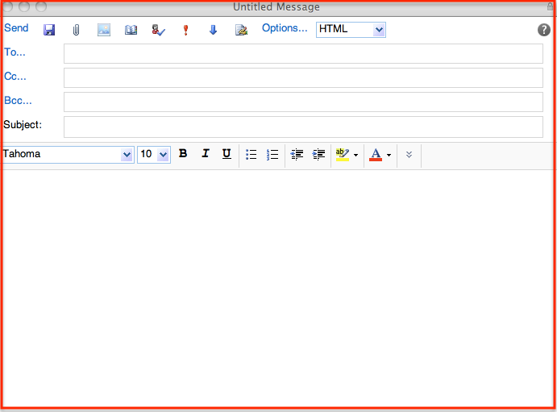
Sincerely,
Your Name

