Self-Advocacy: Emailing Practice
Goals:
1) Write an email to a teacher using respectful language
2) Advocate (help) yourself by expressing your thoughts and concerns
Part 1 Instructions: Answer the following questions then follow the instructions to complete the practice email below. Once you have finished the practice email you will email Mrs. Hutchison.
Questions:
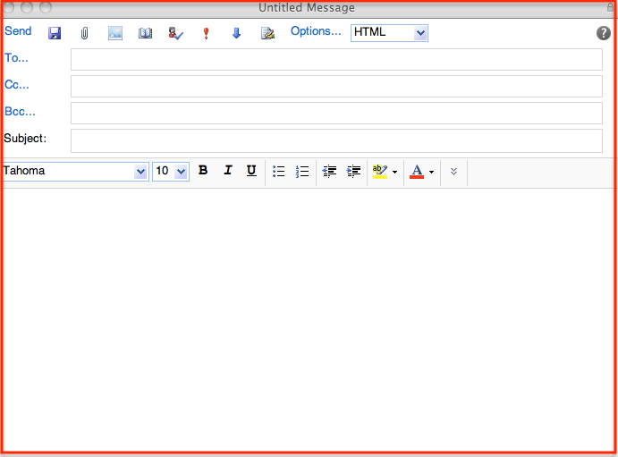
1) What does it mean to advocate for yourself?
2) What are 2-3 examples of respectful language that you should use in an email?
3) When should you use respectful language in an email? List 3 types of people you should use it with.
4) How many times per week do you email someone? Why?
Part 2 Instructions: Now you will write an email response to Mrs. Hutchison. In the email below write her email khutchison@usd116.org or khutchison@urbanasd116.org next to To:. Next to CC: write your email so you will get a copy when it is sent.
Always include a subject. Today’s subject is “My weekend plans”. Then write 1 sentence about your plans for your weekend and ask Mrs. H 1 question. Remember to start with Dear____ or Hi_________and end with Sincerely,______ or Thank you, ________. Check your capitalization, punctuation and spelling.
(10 points)

