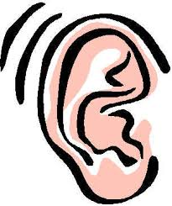
The Arrival Presentation Listening Notes
I heard:

I saw:
I liked:

The Arrival Presentation Listening Notes
I heard:

I saw:
I liked:

