Name Date Class
Travel Journal Practice
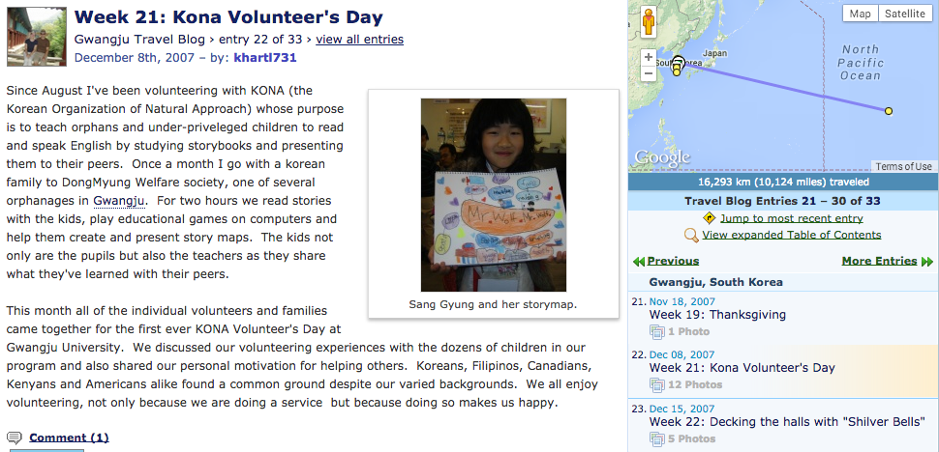
Directions: First you will look at an example of a travel journal and describe it. Then you will create your own travel journal entry.
Part 1: Sample Travel Journal
Questions about the travel journal:
1) Who wrote this journal? How do you know?
2) When was this journal entry written?
3) What are 4 different parts of the journal entry? (Not just writing)
4) What makes this journal entry interesting? Give a specific example and explain why.
5) What makes this journal entry boring? Give a specific example and explain why.
6) Identify 10 different nouns (people, places or things) in the journal entry. List them below.
7) Identify 5 verbs (actions) in the journal entry. List them below.
Part 2: Your Practice Journal Entry
Pre-write (Answer the questions below to help you plan your paragraph. Use the nouns, verbs and synonyms that you found in class yesterday to help you.)
Who went on the journey?
Where did they go?
When was the journey?
What did they take with them?
What did they see and do on their journey?
How did they travel?
How did they feel?
Why did they go?
Journal Entry Paragraph (20 points)
Goal: 5-10 sentences with Capital letters, punctuation (. , ? !) , the verbs went, traveled, took, saw, felt and 10 nouns. (Please underline your nouns or you will not receive points)
Title: By: Date:

Picture with caption (Draw a picture related to your travel journal entry and write a 1-2 sentence description of it below.)

