Part 1: Actively read the article below. Underline at least 1 thing per paragraph and write 3 questions or thoughts on the side of the page. (6 points)
Your eyes are good at physics
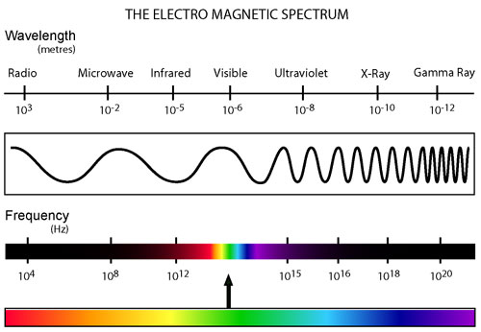
(1) So far, we have learned that color is a form of visible light. The limited spectrum of visible light belongs to the big family of electromagnetic radiation spectrum. Electromagnetic waves are waves that are capable of traveling through a vacuum and just like other every kind of electromagnetic radiation; visible colors also have waves, frequencies and electromagnetic energy. Our eyes can see a very small region of the electromagnetic spectrum (between 400 -700 nanometers of wavelength- corresponding to color range violet through red) and we are unable to see radiation with wavelengths outside this area.
(2) Complementary Color pairs:
We usually do not see colors in isolation. When two colors are side by side, they interact with each other and affect our perception. This is called simultaneous contrast. It is most obvious and intense when the two colors are complementary colors, which are pairs of colors that are diametrically opposite on a color wheel (refer to Herring’s color wheel in the previous page): red and green, and blue and yellow are complementary color pairs. Also, in terms of complementary colors of light; red and cyan; green and magenta; and blue and yellow are complementary pairs. Artists, especially Impressionists, have used the juxtaposing effect of complementary colors for a long time (see Van Gogh’s Starry Night). Do you think they were aware of the neurophysiological terms of complementary colors?

(3) Absorption, Transmission, Reflection, Emission: How our eyes perceive colors!
Now look at your red t-shirt and under white (full-spectrum) lighting, the sun pretty much emits (generates) light at nearly all wavelengths (full-spectrum) in the visible spectrum. Some of the lights emitted by the sun will hit the t-shirt and it will absorb a part of this light. Absorption is a process by which the energy from light is captured by a form of matter. Which wavelengths of light do you think will be best absorbed by the red t-shirt? Since red and cyan light are complementary pairs; your red t-shirt will best absorb cyan light. What happens to the other part of the emitted light if only some of it is absorbed? The red t-shirt will reflect another part of the emitted light. Reflection refers to the process by which the light contacts and is redirected by some form of matter. Red wavelengths of the emitted light will be best reflected by the red t-shirt. From the t-shirt to our eyes, the reflected light is transmitted through the air. Transmission refers to the transit of light through a clear medium. The reflected red light is then transmitted through the air and activates the “red” cone cells in your retina and creates the perception that the t-shirt is red.

Part 2: Use information from the article to complete the chart below.

Vocabulary | Picture/Example | Definition
1 ) Absorption | Is a process by which the energy form light is captured by a form matter
2) Emission
3) Reflection
4) Transmission | 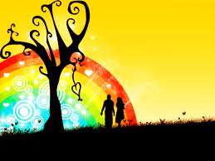 | Refers to the trave of light through a clear medium

Part 3: Identify keywords- Choose 3 more important terms from the article. List them below and write your own definition for each of them.

