Name:______________________________
Getting To Know Transverse Waves
Waves On A String Activity:
- Open Safari
- Go To “google.com”
- Type “Waves On A String Simulation” into the search bar

Click on the 1st link. It says, “Wave on a String - Interference, Harmonic Motion, Frequency - PhET”

It should look like this:

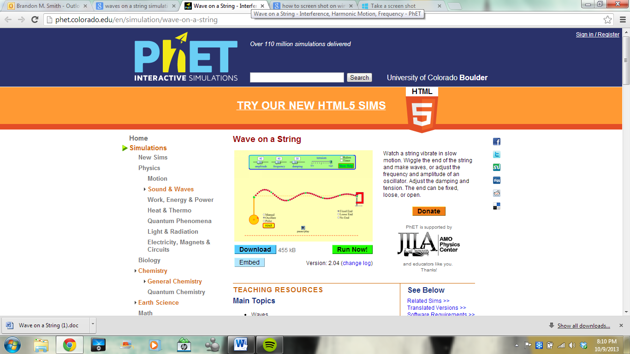

Click the Green Button that says, “Run Now!”

It should look like this:

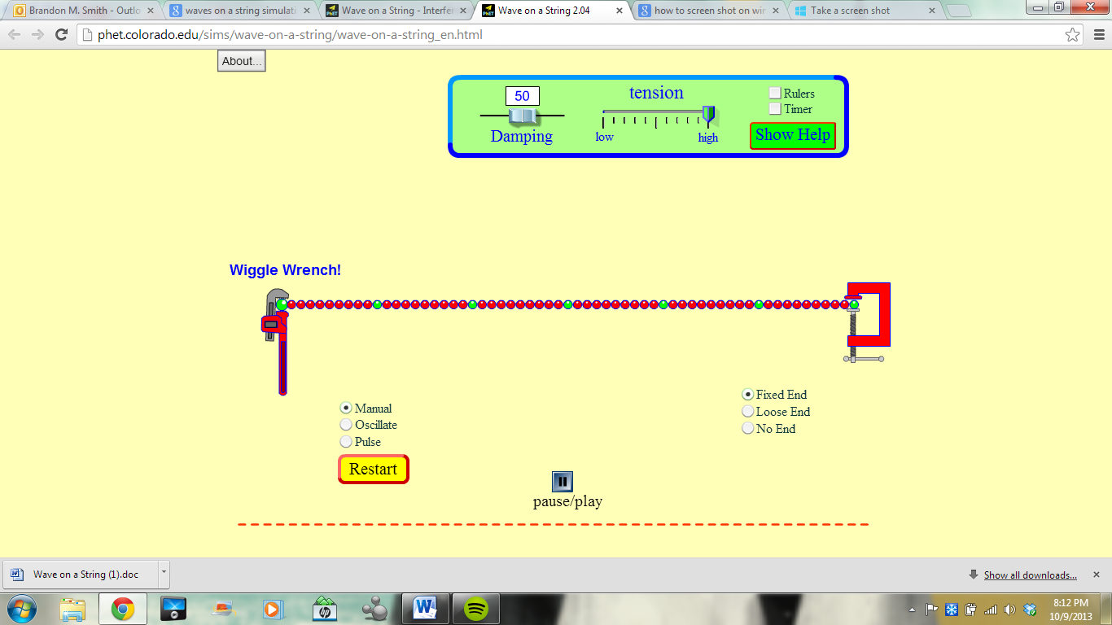
- PLAY AROUND WITH THE WRENCH, CLICK THE DIFFERENT OPTIONS ON THE SCREEN
  - You will have 3 minutes to do your own thing with the simulation.
- Click “Reset”

Measuring Amplitude
- Adjust the damping to 5
- Click “No End”
- Select the box that says, “Ruler”
- Select the box that says, “Timer”
- Select the box that says, “No End”
- Click “Pulse”
- Click “Pause”
It should look like this:
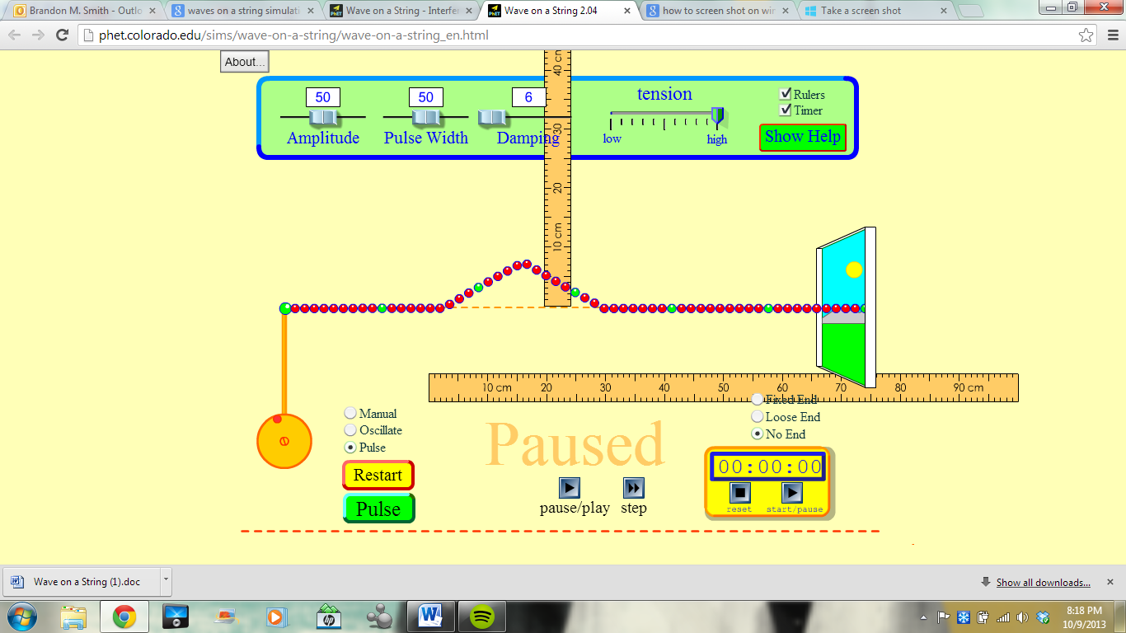
- Use the ruler to measure the amplitude.
- What is the amplitude of the wave?________________________
Measuring Wavelength
Click “reset”
Click “oscillate”
Once the waves start to flow click “pause”
Measure the distance from equal parts of each wave

What is the wavelength?______________________________________
How many waves can you see in the wave train on the screen?______________________________
Measuring Frequency
Click “Oscillate”
Adjust the Frequency to 20
Click “reset”
Start the timer.
Count the number of waves (crests) that travel through the window.
Stop the timer at 10 seconds

How many waves traveled through the window in 10 seconds?______________________

What is the frequency of that wave? (number of waves / 10 seconds)????? Don’t forget your units!!!!!!!!!!________________________________

Practice Calculating Amplitude and Wavelength
Settings:(Oscillate, Damping 5, Frequency 50, No End) (Pause to measure)
Amplitude Setting | Measure Amplitude | Measure Wavelength
100
50
10

Calculating Frequency and Wavelength
Settings:(Oscillate, Damping 5, Amplitude 50, No End) (Use the timer)(Pause to measure wavelength)
Frequency Setting | Time Interval | Number of Waves That Pass The Window |  |  | Measuring  Wavelength
 |  | Trial 1 Trial 2 Trial 3
20 | 10 seconds
50 | 10 seconds
70 | 10 seconds
1. Use arrows, or draw on the wave, to show what will happen when the amplitude is increased:
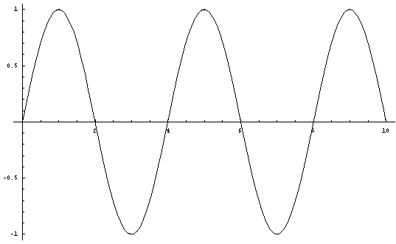

Line of --origin------
- Use arrows, or draw on the wave, to show what will happen when the frequency is increased:

Line of --origin------
Explain what happens to wavelength when frequency is changed….
_________________________________________________________________________________________
_________________________________________________________________________________________
_________________________________________________________________________________________

Explain to someone who has never seen a wave before how they would measure amplitude…
________________________________________________________________________________________
________________________________________________________________________________________

Tell me about 3 different waves that you experience in your everyday life….
_________________________________________________________________________________________
_________________________________________________________________________________________
_________________________________________________________________________________________
________________________________________________________________________________________

