Name Date Class
Writing Practice 1: Describing Pictures
Directions: For each picture below write down words in English that describe the things you see. You can use Google translate or www.wordreference.com to translate specific words and copy them in the Description charts below. Print this document when you are finished.

Picture 1
Source: http://www.usd116.org/uhs/
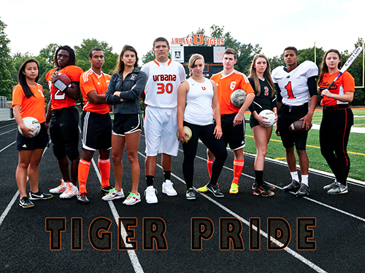
Description Chart (Goal: 3-5 words for each category)
People | Places | Things | Emotions | Colors | Actions

Summary: Write 5 sentences about this picture. Use 10 or more words from the description chart. Underline them after you use them.
Picture 2:
Source: http://hutchisonesl.weebly.com
Description Chart (Goal: 3-5 words for each category)
People | Places | Things | Emotions | Colors | Actions

Summary: Write 5 sentences about this picture. Use 10 or more words from the description chart. Underline them after you use them.

Picture 3: Find your own picture. Copy and paste it below. Remember to include the source (the website where you found it. Google is NOT a source).
Source:
Description Chart (Goal: 3-5 words for each category)
People | Places | Things | Emotions | Colors | Actions

Summary: Write 5 sentences about this picture. Use 10 or more words from the description chart. Underline them after you use them.

